BTRFS

Creating array of disks

# ls /dev/sd*
/dev/sda
/dev/sda1
/dev/sda2
/dev/sda5
/dev/sdb # NEW DISK
/dev/sdc # NEW DISK

# mkfs.btrfs -f /dev/sdb /dev/sdc

# mkfs.btrfs -f -m raid1 -d raid0 /dev/sdb /dev/sdc
- This create automatically raid 0 on data, raid 1 on metadata, raid1 on system
- UUID is the same for /dev/sdb and /dev/sdc
- UUID can be use to mount the FS
- Second command define the metadata as raid 1 and data as raid0
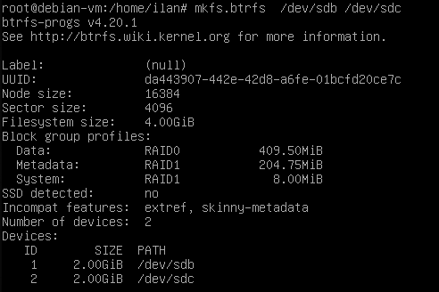

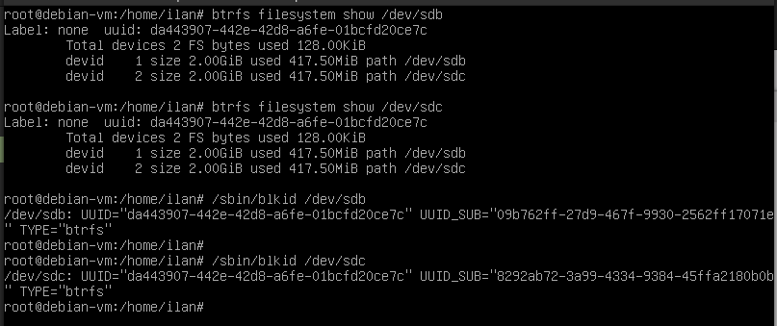
# btrfs filesystem show /dev/sdb
show basic information about the FS /dev/sdb and /dev/sdc. They have the same UUID but each one has it’s own UUID_SUB

MOUNTING THE NEW FS:
# mkdir /NAS
# mount /dev/sdb /NAS
# df -h - doesn’t show the true\real value of the free space. Use this command:
# btrfs filesystem df /NAS
is the correct way to show the actual free space
# btrfs filesystem usage /NAS
Show more detail information about usage and free space
- Device size: 4GB
- Alocated: 835MB
- Unalocated: 3.18GB
- DATA is in RAID0, size 409MB, use 128KB
- METADATA is in RAID1, size 204MB, use 112KB
- SYSTEM is in RAID1, size 8MB, use 16KB
- UNALOCATED: /dev/sdb and /dev/sdc 1.59GB each
- The DATA space will be increase (and compress) automatically when copying data on it

SNAPPER: managing snapshots tool

- Create\Delete snaps based on time

- Making snaps automatically before updating the system (apt upgrade)

- Restore particular files – not restore to whole snapshot
# snapper -c nas create-config /NAS
- -c: config name
- cancel hourly snapping: “TIMELINE_CREATE = “no” in /etc/snapper/configs/nas
# snapper -c nas create
- create new snapshot
# snapper -c nas list
- list of snaps for ‘nas’ config
# snapper -c nas create
- create new snap after deleting some files
# snapper -c nas1 delete 11
# snapper -c nas1 delete 11, 15
- delete snap 11, delete snap 11 and 15
# snapper -c nas status 3..4
- compare backup 3 and 4
# snapper -c nas undochange 3..4
- cancel changing between snap 3 and 4
# snapper -c nas undochange 3..4 /NAS/file1
- cancel changing of file1 between snap 3 and 4
# snapper -c nas diff 3..4 /NAS/file1
- show diff of file1 between snap3 and snap 4
# snapper -c nas delete-config
- delete ‘nas’ config with the whole snapshots

Add device to RAID
# btrfs device add -f /dev/sdx /NAS
- -f force
- This does not enterning the device to the raid
# btrfs fi balance start -dconvert=raid0 -mconvert=raid0 /NAS
- balance add the device to the raid array
- -dconvert: -d for data (you ran choose rain0, raid1, raid5, raid10)
- -mconvert: -m for metadata
# btrfs fi balance start /NAS
- it will balance the raid if you suspect of something wrong

SCRUB
# btrfs scrub start /NAS
- btrfs is a self healing FS. If btrfs see a problem it will automatically fix it
# btrfs scrub status /NAS
- To see the status of scrub command (that run as a process in the background)

